The Writing and Communication Center
2019-2020 Report

Overview:

The Writing and Communication Center (WCC) was founded at NES in September 2011 in connection with the launch of the Joint HSE and NES BAE program. It was conceived as a free and voluntary academic support service for NES students wishing to become stronger writers and speakers in both English and Russian and for NES faculty wishing to integrate written and oral communication into their courses.

We believe that effective communication is a key to academic and professional success, cultural awareness and personal growth. The vision of the Center in the NES community is that of a place where both beginning and advanced writers and speakers can grow, not a "fix-it-shop" where "weak" students go to correct papers. Following the prevalent principles of writing center pedagogy, the WCC at NES concentrates on the strengths and needs of each learner as evident in her work, so she can have a long-term learning advantage rather than a mere editorial service.

Primary Activities:

The primary service of the WCC is one-on-one consultations with students. We offer this service to students in all programs as well as alumni, staff, and faculty. Clients come to us for assistance with a range of projects from course papers and theses to job interview practice. In their work, WCC consultants employ the Socratic method of thought-provoking questions to promote critical thinking and to help students become independent, empowered writers and speakers with distinct voices.

The WCC saw a massive increase in student usage during the pandemic, when all consultations went online. While visits in the Fall were slightly down from the previous academic year (268 in Fall 2019 vs. 309 in Fall 2018), the WCC held 484 consultations during Spring 2020, shattering the previous Spring record of 289 visits in 2018. Unique visitor numbers were relatively flat, suggesting that students who use the Writing Center greatly increased their usage during distance learning.

Continuing a trend from the previous year, students from master’s programs – especially Finance – were the primary users of the WCC, accounting for 456 visits. Staff members and alumni increased their usage from previous years. A breakdown by program can be seen in Figure 1.

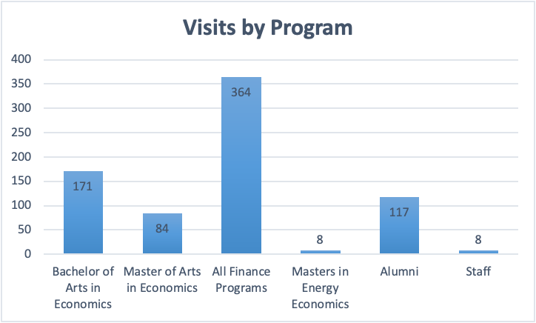
Figure 1. Total Visits by Students of Different Programs

Students have come to increasingly use the WCC to supplement their English classes, especially during the pandemic, when there are fewer opportunities to practice speaking. Over half (57%) of the consultations in 2019-2020 were for English practice. The next most popular category was for graduate school and job applications (20%) (Figure 2).

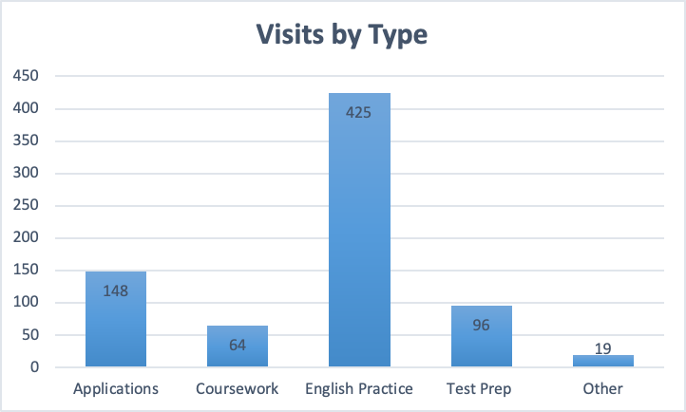

Figure 2. Types of Visits to the WCC

Other Activities:

The WCC held the following workshops during the 2019-2020 school year:

- Navigating the Job Application Process
- Statements of Purpose for Graduate School
- How to Prepare Your Unprepared Speech
- How to Sound English
- How to Write Emails that Solve Problems
- How to Write a Cover Letter
- How to Write an Intro and Lit Review
- Making a Good Impression in Online Meetings and Seminars
- Effective Presentation Delivery

Once NES went into distance learning mode, the staff of the WCC made an effort to create additional opportunities for students to interact and learn. WCC Consultant and English instructor Ekaterina Semenova established a weekly English-language Discussion Club, which has continued into 2021. Director Ashley Squires also hosted a Debate Night.

The WCC also advised faculty members on their syllabi and writing assignments, edited publications for faculty, and edited and translated public documents for various departments at NES.

